SESAR JU bids farewell to Commissioner Bulc

Oct. 23, 2019

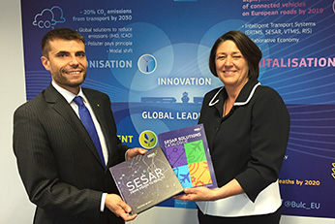On 18 October, the Commissioner for Transport Violeta Bulc visited the SESAR Joint Undertaking premises to meet and bid farewell to the staff who have contributed to all aspects of the research and innovation programme.

Since the start of her mandate, the Commissioner has taken a keen interest in air traffic management, supporting the SESAR JU in its work and outreach, and advocating for change particularly with regards the airspace architecture.

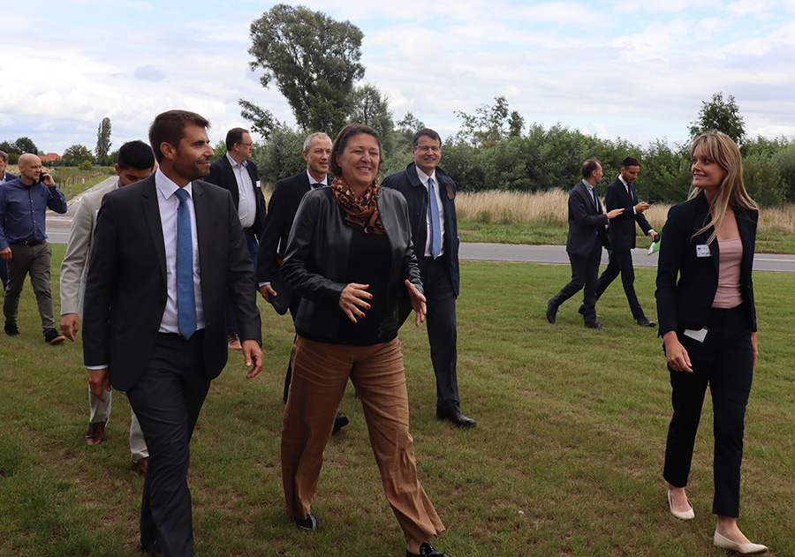She has also been a strong advocate on the safe and the secure integration of drones, having called for the establishment of an enabling framework for drones, otherwise known as U-space, and paved the way for SESAR R&D activities in this area.